William Halton
William Halton is buried at the Sandpits British Cemetery, Fouquereuil, near Béthune, France. He was a Lance Corporal (42978) in the King’s Liverpool Regiment, and died on 1st June, 1918. He was son of Thomas and Hilda Halton, of Shevington Vale. William was born in Dalton-Lees, resided in Appley Bridge and enlisted in Shevington. Lees Lane, Dalton, is east of Appley Bridge, off Appley Lane South, and a mile south of Parbold.
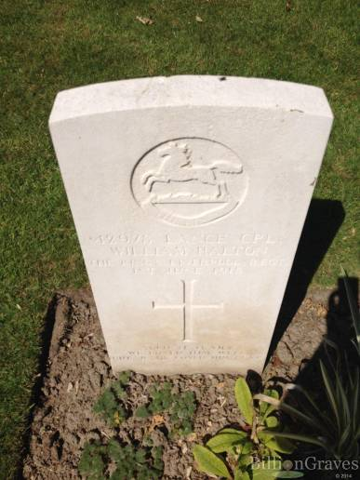
This is a picture of William’s grave at the Sandpits cemetery. The inscription, chosen by the family, says: “We Loved Him Well But Jesus Loved Him Best”.

Below is a picture of the Sandpits Cemetery.
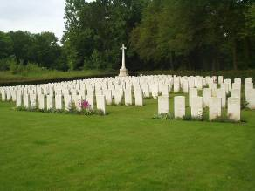
William’s family
William’s was a large family.
In 1901, Thomas and Hilda were living in Dalton-Lees with their nine children. William was the eighth. Father and the eldest son both worked on a farm. Hilda was 40 and must have had her first child when she was 20.
In 1911 the family were living at Lower House, Dalton. There were only five children in the house; the three eldest had probably left home but one of the younger ones may have died. William was 12 years old and still at school. Thomas senior and Thomas junior were both farm workers.
When William died, the family were living in Shevington Vale.
William’s work
William came from a family of farm workers, and would have worked on the farm before joining up.

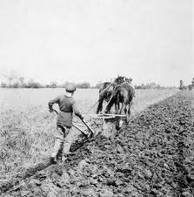
Much of the work would be manual, with only horses for assistance.
What happened to William?
It does not seem possible to identify the precise engagement in which William was killed. He is buried near Béthune, 50 miles south-east of Calais.
Military action around 1st June 1918 seems to have been going on near Soissons, a further hundred miles to the south.
Since William’s body was found and identified, it can be assumed that he was not blown up or left for days on a battlefield. He might have died in a local skirmish or been shot by a sniper.
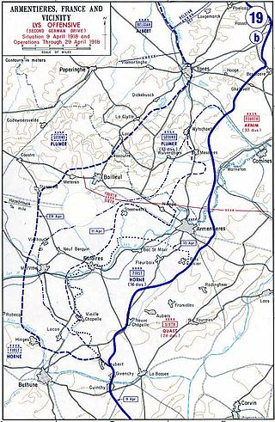
William is buried here.
However, there had been fighting along the River Lys about a month previously, so it was an active area; there would have been many soldiers in position on both sides and frequent raiding parties, just to keep the enemy pinned down and not wishing to withdraw to another theatre to leave a gap in the line.

